1. Go to SE11. Open an existing table in change mode.
2. Click on utilities->Table Maintenance Generator

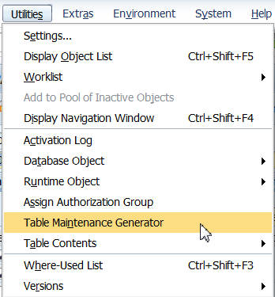

1. Select Authorization Group at &NC& i.e w/o auth. group. Enter the function group name as indicated below. Eg ZXXXXXXFG1. (Non Existing FG)Where xxxxxx is your empcode.
2. Select Maintenance type as One Step.

Click on Find Screen Numbers.

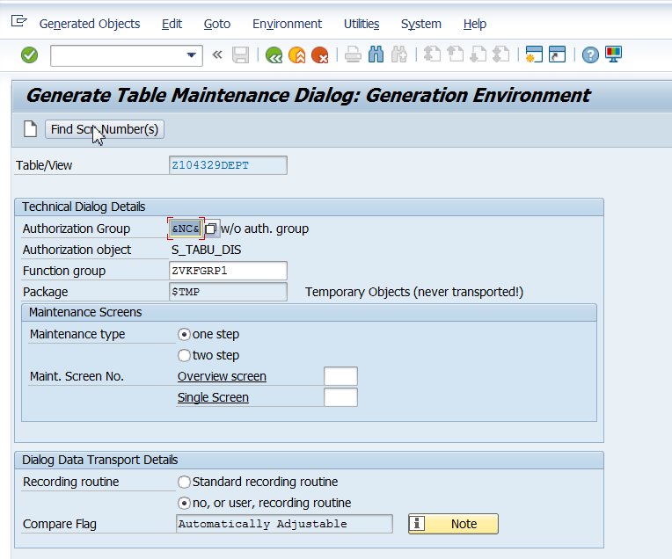

1. Select propose screen numbers. Click on continue.

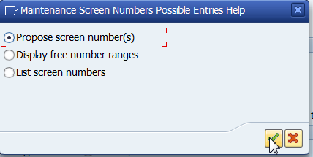

1. Click on create. Save it in package/local object.

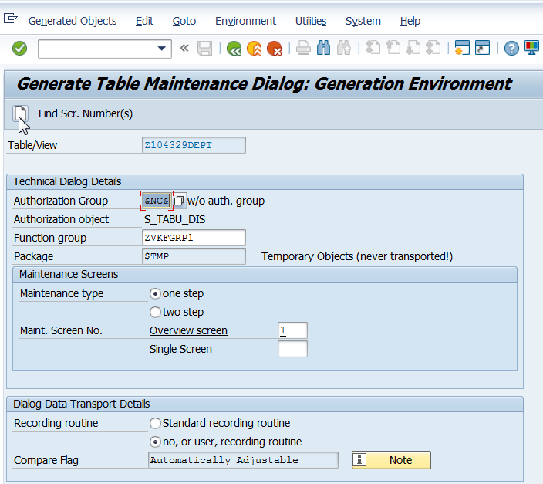

**To be explored by participants**: Recording routine. Standard recording routine vs no, or user, recording routine

1. Go back. Create entries.

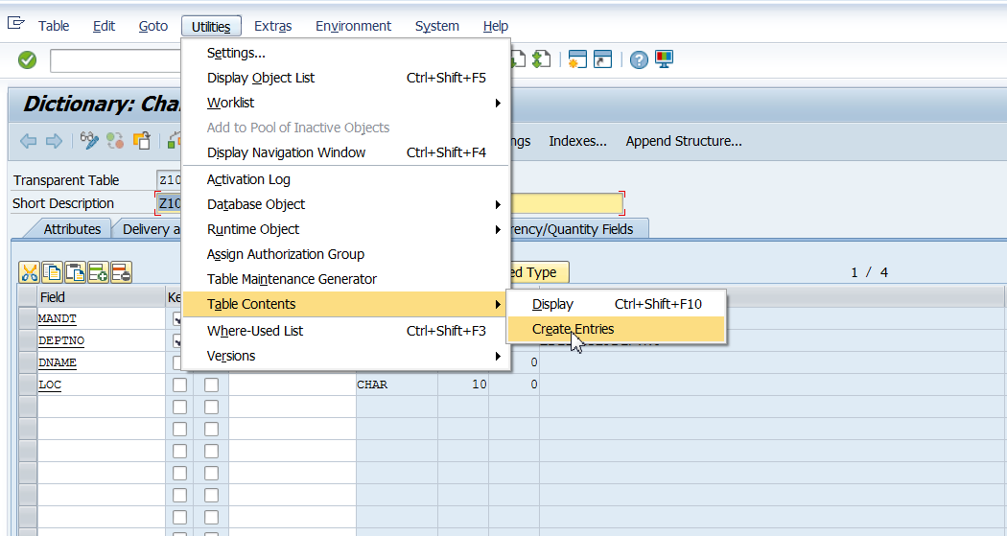

1. Click on New Entries. Existing records may be modified.

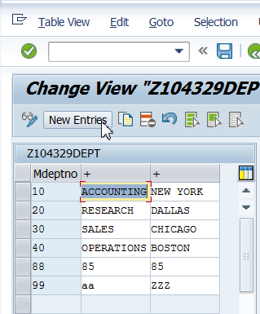

Note: In this case, medium field label is given for Data Element for field deptno. Hence the same is visible as field heading as “Mdeptno”. The labels are NOT given for other fields. Hence only + symbol is visible. It is recommended to give field labels for Data Elements for all fields.